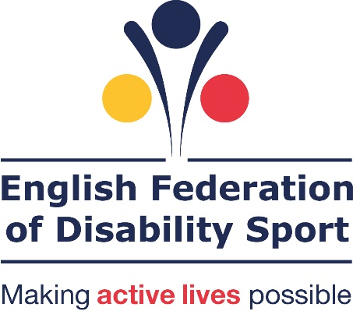

Encouraging more disabled people to volunteer in sport

Fieldwork by Revealing Reality. A report in partnership with Sport England, British Blind Sport, Cerebral Palsy Sport, Dwarf Sports Association UK, LimbPower, Mencap, Special Olympics GB, UK Deaf Sport and WheelPower

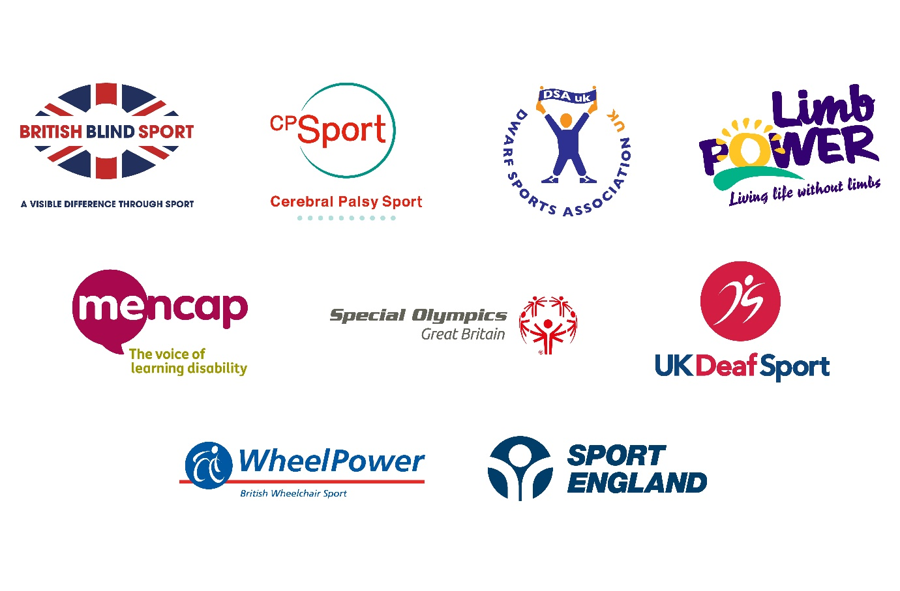
Contents
Introduction 3
Research objectives 5
Methodology and sample 6
Executive summary 8
Understanding the volunteers 10
Understanding the providers 20
Conclusions and recommendations 23
Appendices 27
Appendix 1 27
Appendix 2 28

Introduction

It is well documented that taking part in sport and physical activity has numerous benefits. The physical benefits include improved health and fitness, potential weight loss and improved coordination. There are also significant mental health benefits which can be linked to a sense of belonging and friendship achieved from the social inclusion and interaction.

Participation should not be restricted to playing sport or taking part in physical activity. There are many ways that people can reap the benefits from being involved in physical activity without taking part, including volunteering.

The sport and physical activity sector relies heavily on volunteers to ensure that activities and events take place and are enjoyed. Being a volunteer enables individuals to be part of the environment and gain the benefits without necessarily taking part in an activity. For providers, having a diverse volunteer workforce of different ages, ethnicities and impairments ensures a wider range of experience and knowledge. This encourages creativity and innovation making, their delivery more enjoyable and exciting.

The government sport strategy ‘Sporting Future’ identifies this, stating “it is crucial that the sport and physical activity sector is able to recruit, retain and reward appropriately the volunteers it needs for this strategy to be delivered, that volunteers are suitably representative of the entire population.”

There has been lots of insight work conducted (see appendix 1 for list) around volunteering. It includes understanding the prevalence, the motivations that encourage people to volunteer, the barriers to volunteering and the benefits people get from volunteering. However, there has historically been a significant gap in knowledge around disabled people’s experiences of volunteering, particularly in sport and physical activity. There is some information available, but nothing that looks in detail around disabled people’s experiences of volunteering in general and how they compare to non-disabled people’s views.

The English Federation of Disability Sport (EFDS), alongside the eight National Disability Sports Organisations (British Blind Sport, Cerebral Palsy Sport, Dwarf Sport Association UK, LimbPower, Mencap, Special Olympics GB, UK Deaf Sport and WheelPower) with additional support from Sport England, have conducted this research to fill this gap.

The research includes views from disabled and non-disabled volunteers who volunteer in and out of sport and physical activity. It also spoke to non-volunteers to understand the barriers to volunteering. In addition the research included views and opinions of different providers of volunteering opportunities including organisations such as Tideway Sailability, Get Out Get Active, Volunteering Matters and National Citizens Service (a full list of all provider can be found in the appendix).

The findings are directed toward providers of volunteering opportunities in sport and physical activity (or in general) to help them improve their offer be more supportive and inviting to disabled people. For the majority of the findings, the results refer to volunteering in general, not a specific sector or area. Where findings refer to volunteering in sport and physical activity specifically, this is made clear.

Research objectives

We designed the overall project to understand how and when disabled people volunteer in general and the extent to which they volunteer in sport or physical activity. We want to know what drives and motivates disabled people to volunteer, what prevents them from doing so and how these experiences differ from non-disabled people.

Research objectives
- To understand how common volunteering is among disabled people compared to non-disabled people
- To explore different ways in which disabled people commonly volunteer and where volunteering in sport or physical activity sits in that list
- To determine if there any drivers and barriers to volunteering that are more prevalent for disabled people
- To find how best to encourage and support more disabled people to volunteer in sport or physical activity

Methodology and sample

A two-stage project

Stage 1: Qualitative study
- Literature review
Reviewing available literature from academic and professional bodies to gain a better understanding of the current knowledge around disabled people volunteering. Data gathered was used to design the materials for depth interviews. A full list of literature used can be found in appendix 1

- Scoping interviews
Attending various events, groups and sessions where volunteers would be present to speak to them about their experiences. We also spoke to volunteering providers to understand their opinions and experiences of enabling disabled people to volunteer. A full list of events attended and providers spoken to can be found in appendix 2

- Depth interviews
A total of 30 in person or telephone interviews were conducted with disabled people to understand their views, opinions and experiences of volunteering. A mix of volunteers (in sport and other areas) as well as non-volunteers were interviewed.

The interviews were sampled to equally represent the impairment groups of the National Disability Sports Organisations. The table below shows the split of interviews by impairment.

Blind/ Visually impairment | 7
Cerebral Palsy | 4
Amputee / Limb impairment | 4
Dwarfism | 4
Spinal Cord Injury / Wheelchair user | 5
Deaf / Hearing impairment | 6
Learning disability | 5

Stage 2: Quantitative study
Online survey conducted with disabled and non-disabled people. Sample gathered from omnibus provider and partner organisations.

Total sample | 1426
Non-disabled | 875
Disabled | 551

Blind/ Visual impairment | 148
Cerebral Palsy | 10
Amputee / Limb impairment | 12
Dwarfism | 7
Spinal Cord Injury / Wheelchair user | 91
Deaf / Hearing impairment | 282
Learning disability | 24

No sampling was applied to impairments at this stage, so it is not equally representative.

Acknowledging that an online methodology was not appropriate for some people with certain impairments we held focus groups with people with learning disabilities to test the questions in the survey.

Executive summary

Findings:
- Disabled people are more likely to be motivated to volunteer in general than non-disabled people
  - There are therefore be more likely to currently volunteer as well as be interested in volunteering in the future.

- Despite their higher level of interest in volunteering generally, this is not reflected in their level of interest in volunteering in sport
  - Levels of volunteering in sport are equal between disabled and non-disabled people.

- Disabled people who volunteer in sport are twice as likely to have previously participated than non-disabled people
  - This suggests that the sport sector is not something which appeals to disabled people who have not previously been part of it.

- Volunteering in sport is much more likely to be frequent (at least once a week) which could also be a barrier to disabled people who are fearful of commitment due to fluctuating health problems.

- Disabled people are much more likely to perceive and experience barriers to volunteering in general and be much more likely to have a negative experience of volunteering.
  - This is caused by anxiety in relation to the impact their impairment will have on their ability to volunteer
  - In addition providers of volunteer opportunities feel that they lack the skills and ability to ensure disabled people are fully supported in their volunteering roles.

- There is often a mismatch between the expectations of opportunity providers and volunteers about what volunteer roles entail.
  - This plays a significant role in creating a negative experience for disabled volunteers.

- Providers do not routinely ask or capture whether volunteers have impairments or long-term health conditions
  - This means their level of awareness of disabled volunteers and their needs is low therefore their confidence in how to deal with disabled people is also low

Recommendations:
In order to improve opportunities and the overall experience for disabled volunteers, providers of volunteer opportunities need to:
- Provide clarity on the roles available, the skills needed for those roles and the recruitment process
- Be open and honest to encourage questions and discussions with volunteers
  - This should be encouraged before someone volunteers and ongoing throughout their volunteering experience to capture any changes in circumstance
- Be flexible when volunteers need it, to maximise the benefit providers can gain from them

In addition, the sport and physical activity sector needs to:
- Make the sport and physical activity sector more open and appealing to encourage more disabled people to think about volunteering
- Promote opportunities to wider networks, in an accessible and inclusive way to reach out to people previously not connected to sport or physical activity

Understanding the volunteers

- Disabled people seem to be more interested in and more likely to volunteer in general

Almost half of the disabled people in our survey (47 per cent) currently volunteer in some capacity, compared to just over one third (34 per cent) of non-disabled people. Of those that do not currently volunteer, 54 percent of disabled people said they were interested in doing so compared with 47 per cent non-disabled people.
Figure 1: Charts showing proportion of people who currently volunteer (have done so in the last three months) or who are interested in volunteering in the future
Currently volunteering Interested in volunteering in the future
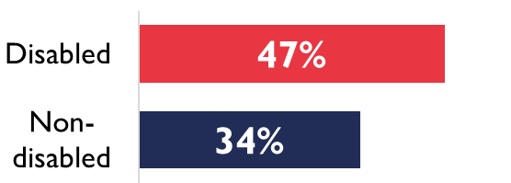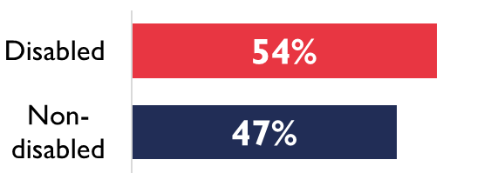

Disabled volunteers are more likely to be older. Almost a third (31 percent) of disabled volunteers are aged 65 plus whereas non-disabled volunteers are more evenly spread across age ranges. The higher level of older volunteers among disabled people is most likely driven by the fact disability is more prevalent as people age.
Figure 2: Age split of current volunteers
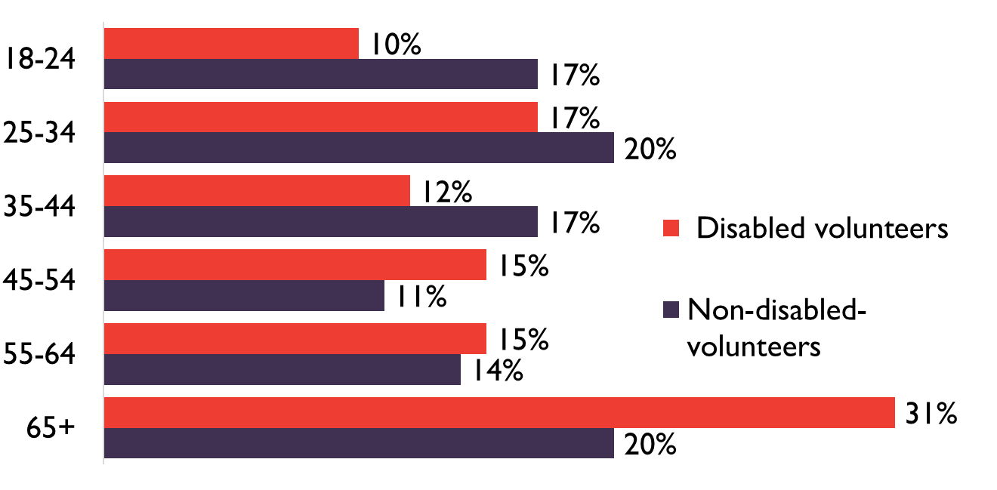

- Disabled people seem more motivated to volunteer

Generally disabled people seem more motivated to volunteer as they are more likely to choose each motivation.
Figure 3: Reasons people volunteer
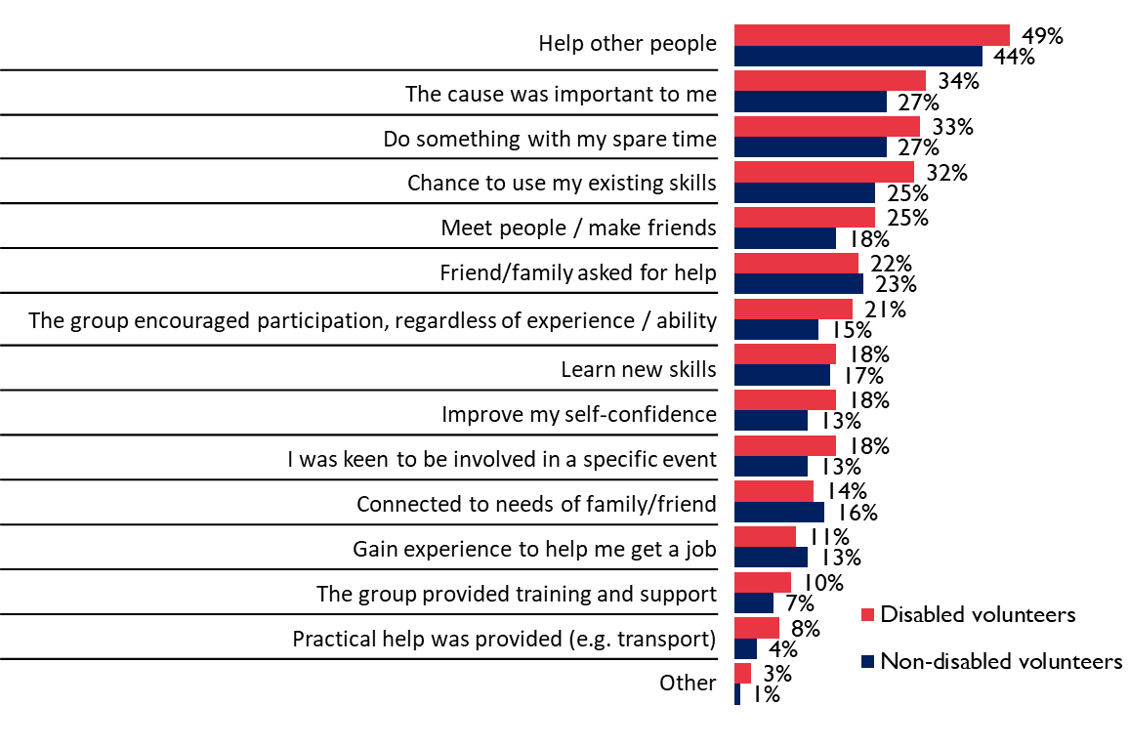
The main motivations to volunteer are the same for disabled and non-disabled people. ‘To ‘help other people’ is the main driver for both groups (49 per cent disabled volunteers, 44 per cent non-disabled volunteers). The cause ‘being important to them’ (34 per cent disabled volunteers, 27 per cent non-disabled volunteers), ‘doing something with my spare time’ (33 per cent disabled volunteers, 27 per cent non-disabled volunteers) and a ‘chance to use skills’ (32 per cent disabled volunteers, 25 per cent non-disabled volunteers) are the next three main drivers.
The qualitative research showed that disabled people are more likely to take part in volunteering for the experience- to be part of something. Whether that is a big event, such as the Paralympics or London Marathon, or to belong to a community which offers social interaction.
Volunteering gives disabled people a chance to use their knowledge and skills to feel useful. It also allows them to give back to society.
“It’s my way of giving something back…if you say you have faith, you can’t just come on Sunday and do nothing”. Volunteer with a restricted growth condition

People who do not currently volunteer see many benefits to volunteering with little difference between the views of disabled and non-disabled people. However, there is one exception.
Figure 4: Chart showing the proportion of non-volunteers that agree with each statement
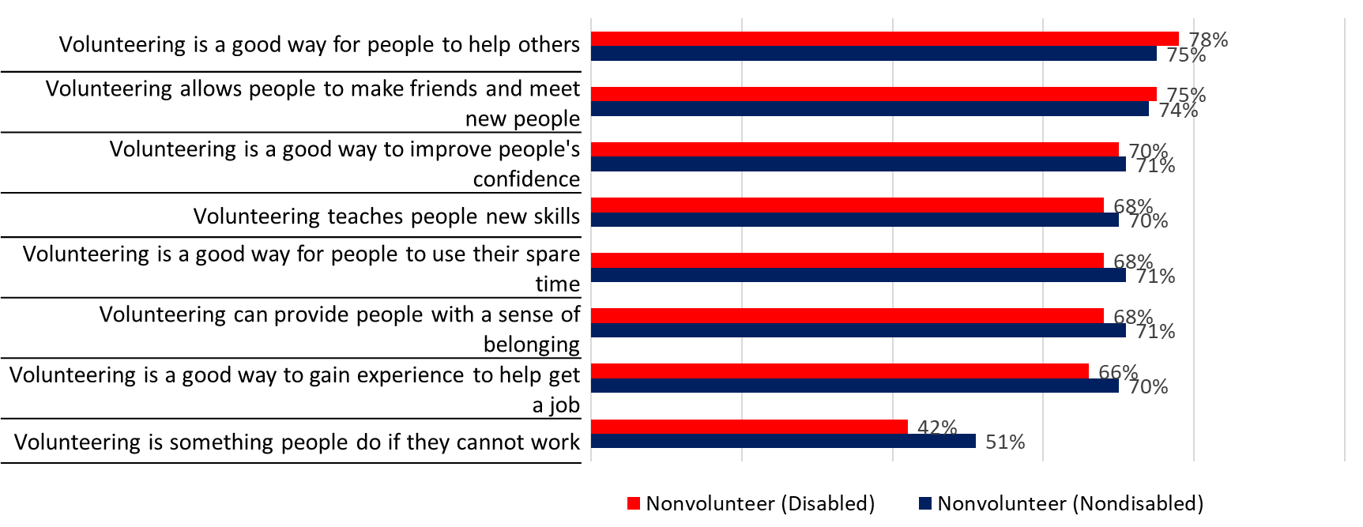
Non-disabled people are more likely to agree ‘Volunteering is something people do if they cannot work’ (51 per cent) compared to disabled people (42 per cent).

- Despite the higher levels of interest and involvement in volunteering, disabled people are more likely to perceive barriers to volunteering and have a negative experience

Of those people who do not volunteer, disabled people are generally more likely to identify barriers than non-disabled people. The qualitative research found that the biggest barriers for disabled people who were not volunteering centred on anxiety about how others will perceive their impairment or health condition. The quantitative research discovered that the gap between disabled and non-disabled people was noticeably larger for those barriers related to anxiety.
A quarter of disabled people (25 per cent) are concerned that organisations would not be able to support someone with their needs compared to less than 1 in 10 (9 percent) non-disabled people. Almost three times the number of disabled people, 21 per cent, believed that the venues where the volunteering takes place would not have suitable access for them compared to 8 per cent of non-disabled people. Disabled people (17 per cent) are also twice as likely to be concerned that they may be treated differently to other volunteers compared to non-disabled people (8 per cent).

Figure 5: Perceived barriers to participation
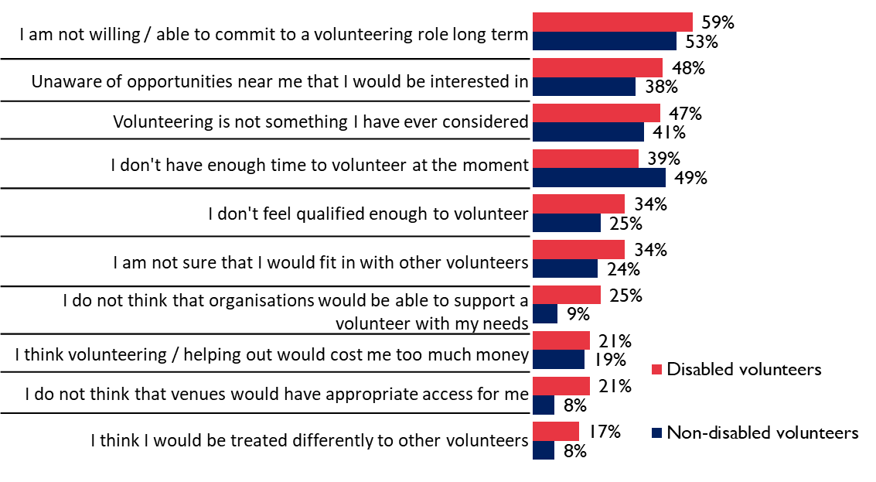
There was one exception where a barrier was more prevalent for non-disabled people. That was ‘having time to volunteer’. A lack of time is less of a concern for disabled people, possibly a reflection of the older age bracket that disabled volunteers fall into, therefore more likely to be retired with more time to spare.
Despite being more likely to volunteer and being more motivated to volunteer, disabled people were also much more likely to have a negative experience whilst volunteering.
Figure 6: Chart showing proportion of volunteers having negative experiences
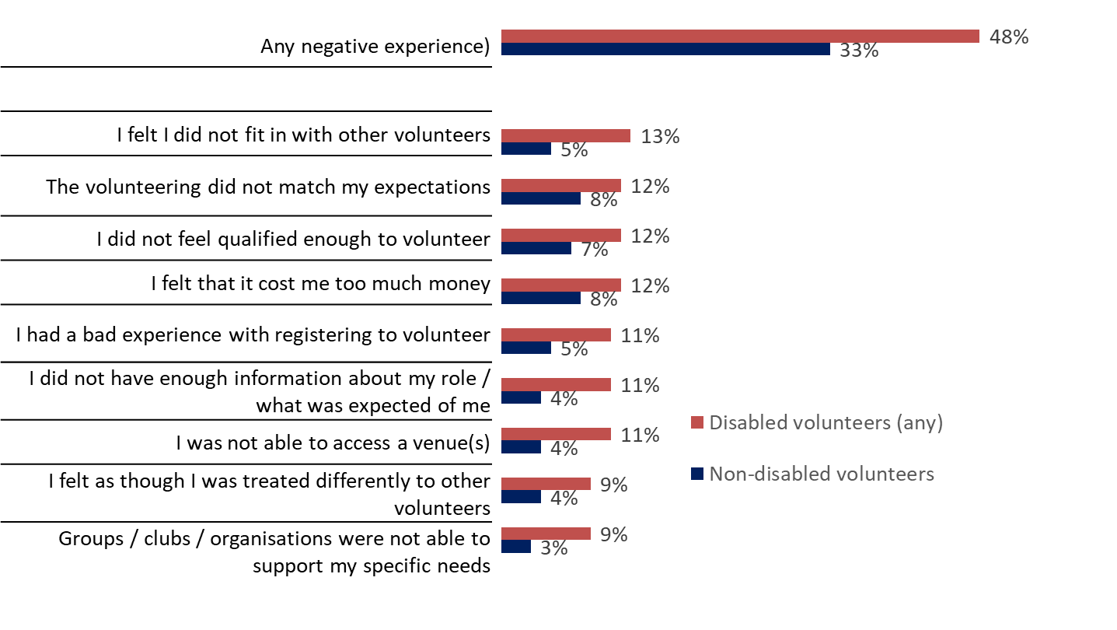
Nearly half of disabled volunteers (48 per cent) said they had a negative experience compared to one third (33 per cent) of non-disabled volunteers. The reasons behind the negative experience were varying, but always more likely to be experienced by disabled people.

- Disabled people seem to be more likely to volunteer in all types of role, with the exception of organising or helping to run an activity

Generally, there is a greater proportion of disabled people volunteering in all types of role with one exception. Just over a quarter (26 per cent) of disabled people volunteer in ‘organising or helping to run an event’ compared to almost one third (31 per cent) of non-disabled people. This is the second most common role for non-disabled people.
This role seems to be less appealing to disabled people, the reasons for which were not made clear within this research.
Figure 7: Types of roles that people volunteer in
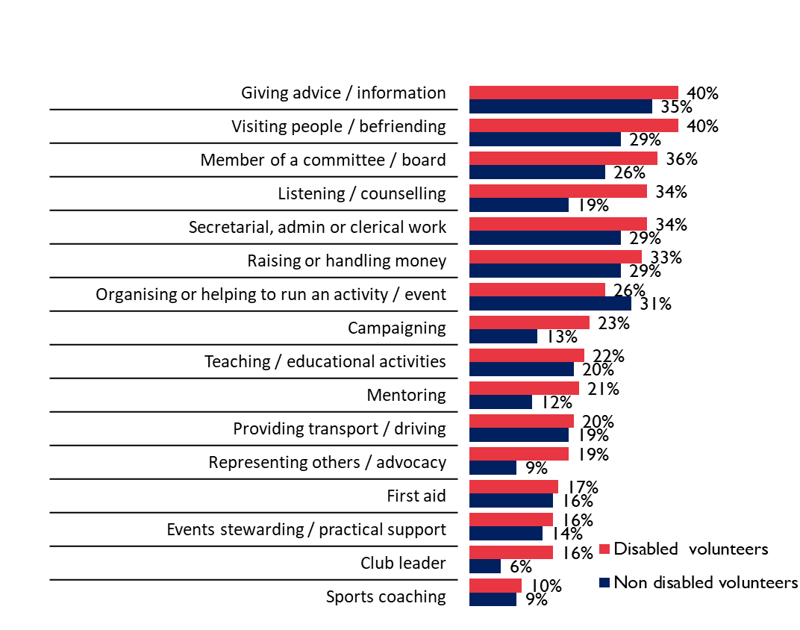
For some roles, disabled people were significantly more likely to volunteer. Disabled people are almost twice as likely as non-disabled people to volunteer in a listening / counselling role (34 percent vs 19 per cent respectively).
Other roles, which are not necessarily significantly different, but there is at least a 10 per cent difference include:
- Visiting / befriending people (40 per cent disabled people, 29 per cent non-disabled people)
- Member of a committee / board (36 per cent disabled people, 23 per cent non-disabled people)
- Campaigning (23 per cent disabled people, 13 per cent non-disabled people)
- Representing others / advocacy (19 per cent disabled people, 9 per cent non-disabled people)
- Club leader (16 per cent disabled people, 6 per cent non-disabled people)

- Disabled people are generally more likely to volunteer in all sectors with the exception of sport and education.

Generally, disabled people are more likely to volunteer in all sectors, except for sport and education where the level of volunteering is equal.
Sport volunteering is the most common type for non-disabled people, with 1 in 5 (21 per cent) volunteering in this area. This is closely followed by education (19 percent) and local or community issues (19 per cent). However, sport is only the 3rd most popular sector for disabled people, with local or community issues (29 per cent) and health, disability or welfare (28 per cent) being significantly more popular.

Figure 8: Sector where people volunteer
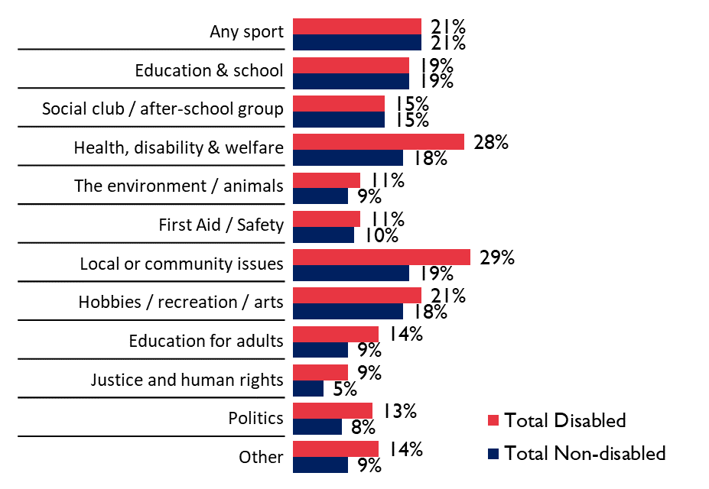

The figure for volunteering in sport includes mainstream and disability sport. When broken into the two groups, volunteering in mainstream sport was more prevalent for both disabled and non-disabled people with around 2 in 10 volunteering in that sector (20 per cent of non-disabled people, 18 per cent of disabled people). Volunteering in disability specific sports was much less prevalent, with 6 percent of disabled people volunteering and only 3 per cent of non-disabled people volunteering.

Figure 9: Proportion of people volunteering in mainstream and disability specific sport
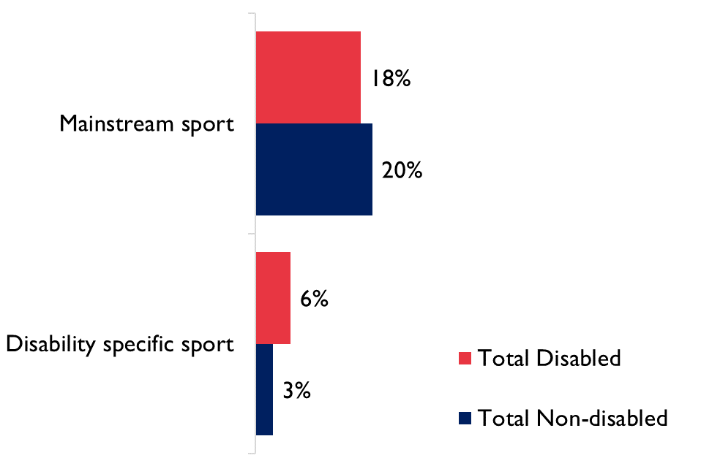

Although the volunteer figures for disability sport are low, it shows that disabled people are twice as likely as non-disabled people to volunteer in disability sport.

For those who currently volunteer in sport, they were asked why they did so. There were clear differences between disabled and non-disabled people.

The lower interest in sport volunteering among disabled people is noteworthy. The qualitative research showed that disabled people who do currently volunteer in sport see many benefits of doing so, which include:
- The social aspect of sport
- The focus on working together and supporting each other
- There is an “air of fun”
- Sporting spaces are memorable and unique:
  - Sport environments often have a community feel
  - They are part of their identity
  - People want to be in these environments

Understanding why some people volunteer in sport can perhaps help us to understand why others don’t.
Disabled people are most likely (and twice as likely as non-disabled people) to volunteer in sport because they used to be a participant or use the services they provided. Whereas non-disabled people most commonly volunteer in sport because a friend or family asked for help. The motivations to take part earlier highlighted that disabled people are less likely to volunteer to help friends and family.
Figure 10: Reasons people volunteer in sport
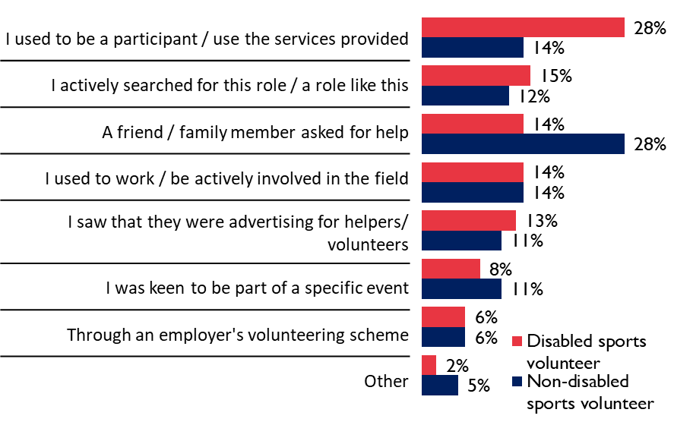

This can provide some insight into why sport may not be as attractive to some disabled people. They may feel excluded from the sporting environment. Having never played sport, they may feel that volunteering in the sector is not for them. They may require evidence that ‘someone like me’ currently volunteers and enjoys it. Disabled people could have lots of skills that would be welcome in the sport sector, but it seems more needs to be done to encourage them to consider volunteering in the sector first.

Some additional insight could perhaps be gathered from how frequently people volunteer in different sectors.
Volunteering weekly is most common in the sport sector with almost half (49 per cent) of all volunteers, disabled and non-disabled, volunteering at least once a week in sport and almost 4 in 10 (39 per cent) volunteering once a week in disability sport.
Figure 11: Chart showing proportion of all volunteers who volunteer on a weekly basis in each sector
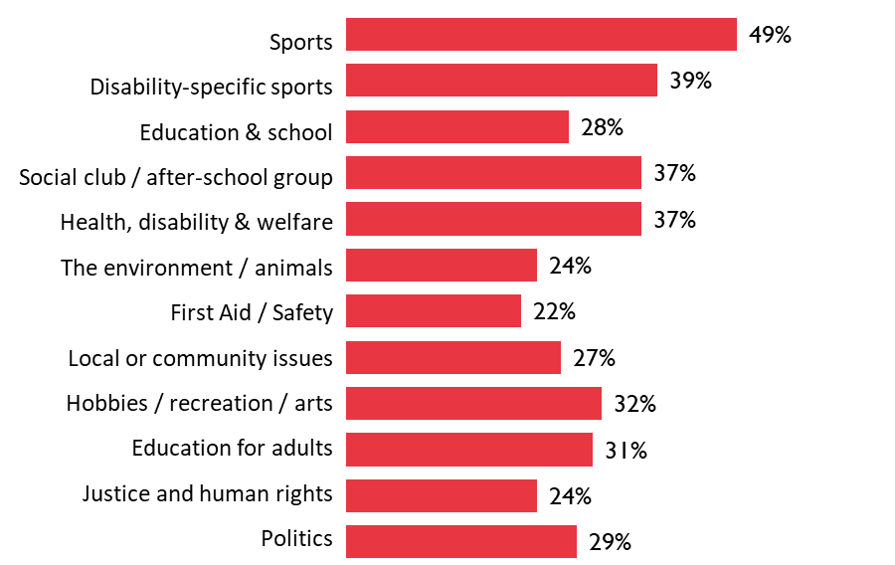
Having to commit to volunteering regularly can be a significant barrier for disabled people, as identified in the qualitative research.
Disabled people were cautious about committing to things long term. 6 in 10 stated this as a barrier earlier in the report. In the qualitative work, it was identified that they were anxious that if they committed they may let people down due to fluctuation in their health preventing them from attending. More flexible approaches to volunteering are welcomed, to minimise their fear of disappointing others.

Understanding the providers

Alongside the volunteer’s experience, it is important to understand the views, opinions and current experiences of providers when offering opportunities for disabled people to volunteer. A number of diffe3rent providers were included in this research, a list of which can be found in the appendix. This list is heavily influenced by providers of sport.

- Current awareness and support of disabled volunteers is low among providers because they do not routinely ask or capture whether volunteers consider themselves to be disabled

Asking whether volunteers are disabled is not a routine question that is part of recruitment. Providers are nervous to ask in case they offend people. This means that providers are often unaware of any disabled volunteers (unless the impairment is obvious) and therefore not prepared for any additional support needs a person may have.
Even where impairments are obvious, without having a discussion with an individual, because the provider does not make an opportunity to do so, it is difficult for providers to understand the person’s support needs. They therefore make assumptions about the individual’s ability and associated support needs, which can often be wrong.
“Knowing when to step in, and when to step away tends to be the biggest mistake to make”
Volunteer with a learning disability

There is a lack of process which encourages honest and open dialogue about impairments and the associated needs. Disabled people who volunteer are often reluctant to tell people about their impairment due to bad experiences in the past or not wanting to make a fuss. But they also would prefer to feel more comfortable about highlighting support needs, rather than their impairment being ignored. They do not want to be a reason for some formal training but would like to be confident their needs will be met.
I’d hate there to be some kind of formal disability training, or meeting about me”
Volunteer with restricted growth condition

“We had a really productive discussion about what I could and wanted to do, and she was really supportive of that since then”
Disabled Volunteer

Providers want to feel more confident in approaching the subject, ensuring a useful and effective conversation, rather than something which may upset or offend somebody. If they have a conversation, everyone has a better understanding of the volunteer skills and abilities and which roles would be most suitable.
“Matching is really important! – We’re very open about asking if people have any additional needs. When you find people that are well suited – both parties benefit.”
- Volunteering Matters

- There is a mismatch between provider and volunteer expectations which plays a significant role in creating a negative experience for disabled volunteers.

Volunteers often have a negative experience if their expectations are not aligned with what the provider expects from them.
“I was told that I’d be giving visitors information in Buckingham Palace Gardens – when I got there, there had been a change of plan, I was in a boiling hot porter cabin, handing out tickets”
Volunteer, wheelchair user

Providers who focus solely on the outcome for which the volunteer is needed, rather than the volunteer experience, are more likely to have dissatisfied volunteers. Providers need to be clearer about what the volunteer roles entail. What do they expect from volunteers in terms of time commitment and skill level?
Figure 12: Matrix of volunteer and provider expectations
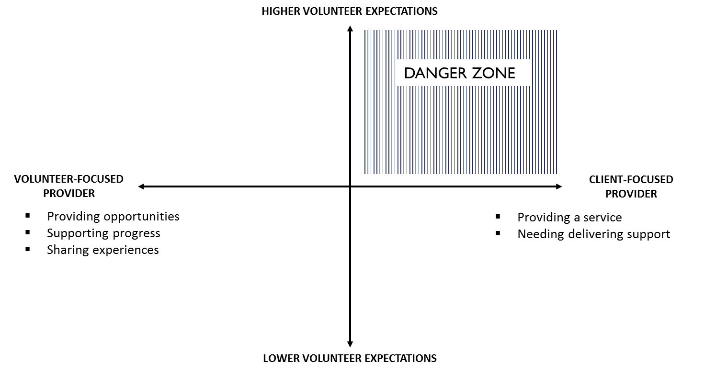

Giving volunteers clear guidance on what they are signing up for, and the process of allocating roles can help volunteers manage their expectations. Understanding how rejection is dealt with is also important to disabled people, as often they assume they have not been recruited because of their impairment.

- Disabled volunteers require more flexibility on time commitment but providers need to ensure they have the relevant human resources for the task in hand

Disabled volunteers have told us they can sometimes have a fear of commitment. Often, due to complications linked with their impairment they are fearful of regular volunteering in case they are unable to attend due to health fluctuations. Providers are often keen to have commitment to a role which may frighten disabled people from considering it.
“We really struggle to keep people with us. That’s why we ask for some commitment at the start – normally looking for about six months from them”
Volunteer Manager, Local homelessness charity

If providers could be more flexible with the role allocation and people’s commitment to it, disabled people would be more encouraged to volunteer. They would be less likely to disappoint people if they were unable to attend, but also gain the benefits from attending when they were able to. This also means that providers will not miss out on the skill set disabled people could bring to the organisation.

Conclusions and recommendations

Our research shows that there is a clear demand from disabled people to become volunteers, although the drive to volunteer in sport is less than other sectors. Disabled people are also much more likely to have a negative volunteering experience. This seems to be because providers are often ill prepared to support disabled people effectively.
We have highlighted a number of things that providers can do to improve the experience for disabled people. This will help to ensure that those disabled people who are already volunteering have a positive experience as well as encourage more disabled people to volunteer.

- Providing clarity on the roles available, the skills needed for those roles and the recruitment process

Make sure disabled people are fully aware of what is expected of them as a volunteer.

Recommendation | Impact
Give clear guidance on what the roles will be and what skills sets are needed for the roles. Develop recruitment templates – outlines of the best way to recruit people. Identify which information needs to be included, what questions needs to be asked and ensure the same process is always followed. | Providing more clarity means disabled people are more likely to know what to expect. They can make a more informed decision as to whether the volunteering opportunity is right for them. They can also plan for their day and its management.  Having a template means that a consistent approach is followed and applied to all roles.
Include a clear outline of the application and recruitment process. Detail how decisions are made as to who will be given each role and the potential need for flexibility in role allocation. | Knowing the recruitment process and how roles are allocated helps disabled people to plan. To determine whether the roles available are suitable for them, and if they have to take another role, whether they would be able or willing to do so
Outline how rejection is handled. If an application is unsuccessful how do providers let people know? Make this clear up front. | Disabled people will feel more reassured about the process and less likely to interpret any rejection as a result of their impairment
Provide introduction packs that includes this information | Having a go-to resource ensures everyone knows where the information is held and stored

- Be open and honest and encourage questions and discussions with volunteers

Provide an opportunity for volunteers to discuss their needs with the organisation in an inviting and friendly environment

Recommendation | Impact
Develop training / guidance on conversation tools to overcome awkwardness. It can include things not to be afraid of. Ways in which to approach sensitive subjects. Make sure to highlight why it is important to do this. | People are often nervous about upsetting a disabled person by using the wrong terminology. Having a toolkit available to refer to helps build confidence and means the important conversations about what help and support is needed can be had without embarrassment.
Provide opportunities for volunteers to ask questions – make it obvious that the organisation is happy to answer them. Either through ‘ask me’ sessions during events, or through email or social media channels during recruitment | This gives disabled people an opportunity to reach out and ask questions to help them determine whether the opportunity is for them. It also means that providers are more aware of the people volunteering and the needs they may have
Make it clear in the marketing for volunteer opportunities that disabled people are included in the organisation – using images and stories of the people involved | This helps disabled people see that providers have supported other disabled people to be part of the organisation.

- Be flexible to maximise the benefit you can gain from volunteers

Try to be less rigid about the time and commitment volunteers need to give. Develop strategies to help you manage fluctuation better so everyone can benefit.

Recommendation | Impact
Be as flexible as possible about volunteer commitment | This will encourage more disabled people to volunteer
Maintain regular contact with irregular volunteers. Whether it be via email or newsletter, make regular connections to let them know the organisation are aware they are there and still need them. | This lets volunteers know that they are still important to the organisation, and might make them think about reaching out and asking for new and different roles.
Try and capture the skill sets of all volunteers (in a database maybe) and routinely review to see if volunteers could be used in new and different ways. | This means providers have a better understanding of the skill there is among volunteers, so if one person is unable to attend they can find a replacement. It also means they can allocate tasks to people with relevant skills
Offer volunteers the opportunity to change roles and tasks | If someone has been volunteering for a long time they may become bored and not want to continue. Offering them opportunities to try something new will keep them with you and also perhaps identify skills that may be useful and relevant

- Make the sport and physical activity sector more open and appealing to encourage more disabled people to think about volunteering

A vast majority of sport and physical activity volunteers are from people who are already involved or have friends and family involved in the sector. The challenge is to encourage those who are not already engaged to consider volunteering in this sector as something for them.

Sport and physical activity has so much to offer people it should be used to attract new volunteers to the sector. Encouraging those who do not see themselves as sporty and making the volunteers an integral part of the team / club so they reap the benefits as well.

Recommendation | Impact
Make it clear the range and scope of roles available and the different skill sets that are needed. | It can make people understand how diverse the sporting landscape can be, and that even though they may not be interested or able to participate they could still be involved.
Advertise the roles available more widely, to reach outside of the sector (use more friendly terminology to be more open and inviting.  Link to https://www.sportenglandclubmatters.com/club-people/volunteers/finding-volunteers | This will give providers access to a much wider pool of people with new and different skills that they can benefit from.
When holding taster sessions for the club or group make the volunteering opportunities part of those sessions. Make it clear that people can volunteer as well as participate | Using open days to attract participants and volunteers is a more efficient use of time. It also leads to closer group cohesion
Ensure volunteers are part of social interaction alongside club / team members | Including volunteers in all social events results in a bigger happier family, and more people to provide help and support if needed
If your club does not currently have any disabled participants, help increase awareness of disability by holding sessions with groups or teams who do have disabled members. Show them the volunteering opportunities available, to highlight that they can get involved in sport and physical activity in other ways than just taking part | This increases awareness of disabled people making them less fearful of negative stereotypes. This also increases the exposure of your club to disabled people and lets them see what opportunities to have available

- Promote volunteer opportunities within sport and physical activity setting to wider networks, in an accessible and inclusive way, to reach out to people previously not connected to the sector.

Sport and physical activity volunteering seems to rely heavily on word of mouth or past / current involvement in the sector. Making a conscious effort to reach out to the wider community to try and recruit new volunteers will help generate a more diverse volunteer base with usable skills.

Appendices

Appendix 1
Literature review sources

- http://www.spd.org.sg/updates/detail/barriers-to-integrating-people-with-disabilities-in-mainstream-society-72.html
- http://www.efds.co.uk/how-we-help/fact-and-statistics
- Sport England, 2016. Mapping Disability – The Facts. https://www.sportengland.org/media/3988/mapping-disability-the-facts.pdf
- https://data.ncvo.org.uk/a/almanac16/motivations-and-barriers-to volunteering-2/
- https://www.ncvo.org.uk/practical-support/consultancy/volunteering-consultancy
- Sport England (2016) Motivations of Sport Volunteers in England, A Review for Sport England.
- Cabinet Office. (2015). Community Life Survey 2014–15, Excel Tables. London: Cabinet Office
- http://blogs.ncvo.org.uk/2015/01/26/harnessing-disabled-peoples-ability-to-volunteer/
- http://www.volunteernow.co.uk/fs/doc/publications/involving-people-with-disabilities-as-volunteers-poster.pdf
- http://blogs.ncvo.org.uk/2015/01/26/harnessing-disabled-peoples-ability-to-volunteer/
- https://www.theguardian.com/voluntary-sector-network/2013/aug/14/disabilities-difficult-volunteering-roles
- National Council for Voluntary Organisations Website “Supported Volunteering for Adults with Disabilities - CSV Vocal Project Case Study” https://knowhownonprofit.org/case-studies/supported-volunteering-for-adults-with-disabilities
- http://www.bhcommunityworks.org.uk/members/advice-support/good-practice-guide/planning/removing-barriers-to-volunteering/
- https://www.theguardian.com/voluntary-sector-network/2011/jun/03/best-bits-barriers-community-action-volunteering
- Disability Equality (2013) Good Practice in Supported Volunteering. Preston.
- National Council for Voluntary Organisations Website “How to develop an inclusive supported volunteering scheme” https://knowhownonprofit.org/how-to/how-to-develop-an-inclusive-supported-volunteering-scheme
- Rowe, N. 2012. Sporting Capital — a new theory of sport participation determinants and its application to ‘Doorstep Sport’ A report commissioned by StreetGames
- Sport England Website “I want to offer volunteering opportunities to disabled people and others who have additional support needs. How do I go about this?”. URL: https://www.sportengland.org/our-work/volunteering/volunteering-explained/diversity/i-want-to-offer-volunteering-opportunities-to-disabled-people-and-others-who-have-additional-support-needs-how-do-i-go-about-this/
- EFDS. January 2016. Supporting me to be active: the role of supporters in influencing disabled people to be active.
- David French & Jenny Hainsworth. December 2010. 'There aren't any buses and the swimming pool is always cold!': obstacles and opportunities in the provision of sport for disabled people. Managing Leisure. Volume 6, 2001 - Issue 1
- https://www.sportanddev.org/en/learn-more/disability/sport-and-adapted-physical-activity-apa/barriers-participation
- EFDS&2CV. October 2014. ‘Talk to Me: Understanding how to increase participation in sport and physical activity amongst disabled people in the UK’. http://www.efds.co.uk/how-we-help/research/1878-talk-to-me-october-2014
- Sport England & EFDS. March 2016. ‘Mapping Disability – Encouraging disabled people: The Guide’. https://www.sportengland.org/media/10857/engaging-disabled-people_the-guide.pdf

Appendix 2

List of providers

BID Services: Birmingham institute for the deaf
Disability Sports Coach
Action on hearing loss
National deaf children society
Special Olympics GB
Tideway Sailability
Stoke Mandeville Stadium
SportStart
Access Sport
Inclusive Futures
Get Out Get Active
Spirit 2012
Bendrigg Trust
Volunteering Matters
Motivate East
(Partners: London Legacy Development Organisation)
Street Games
Team Westminister Active
National Council For Voluntary Organisations
Vinspired
Sports Volunteering Network
Saracens Rugby Club
National Citizens Service
Do it
Volunteers @ Somerset House
Volunteer Centre Kensington & Chelsea
Limpbower
DeafSport
BBS
CP Sport
DwarfSport
Mencap
Special Olympics
WheelPower

