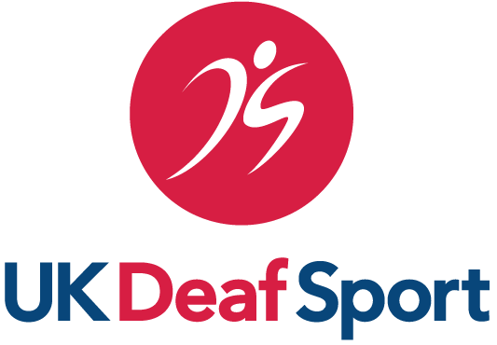 |  | 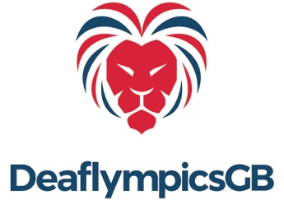

UK Deaf Sport Athlete Advisory Group
Member Application Form

BSL Translation - https://youtu.be/XAelEOPB-P0

Please complete this form to apply to join the UK Deaf Sport Athlete Advisory Group (AAG).

See the attached guidance notes regarding the AAG, selection criteria, time commitment and term limits.

Completed forms to be sent to info@ukds.org.uk 5pm Wednesday 25 January 2023.

Name and contact details:

Which deaf sport/s do you currently compete in/have you competed in in the last 4 years?

List your national and international experience in deaf sport/s:

Why do you want to join the UKDS Athlete Advisory Group?

Max 500 words
What skills, knowledge and experience do you have that will help the Athlete Advisory Group meet its aims, purpose and responsibilities as set out in the Athlete Advisory Group guidance notes?

Max 500 words
Any other information you feel is relevant to your application?

Let us know the details of any involvement (voluntary or paid) with any sport body or organisation.

Max 250 words
Would you like to be considered for the role of AAG Chair? | Yes/No
UKDS Athlete Advisory Group Guidance Notes

