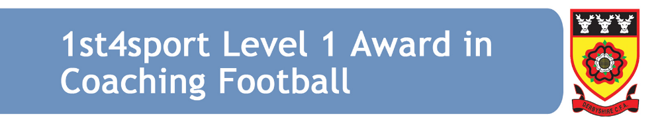
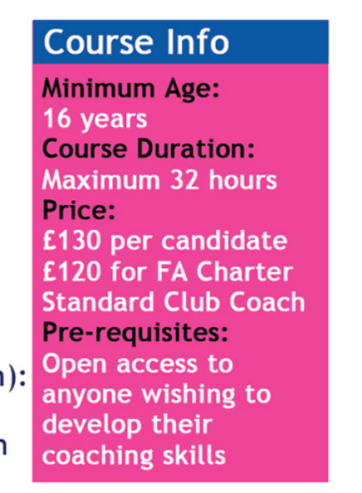
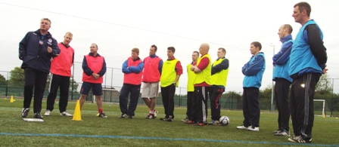
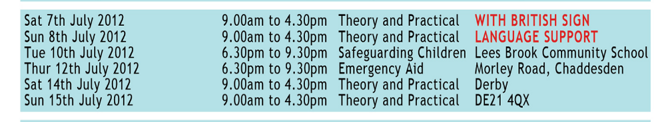
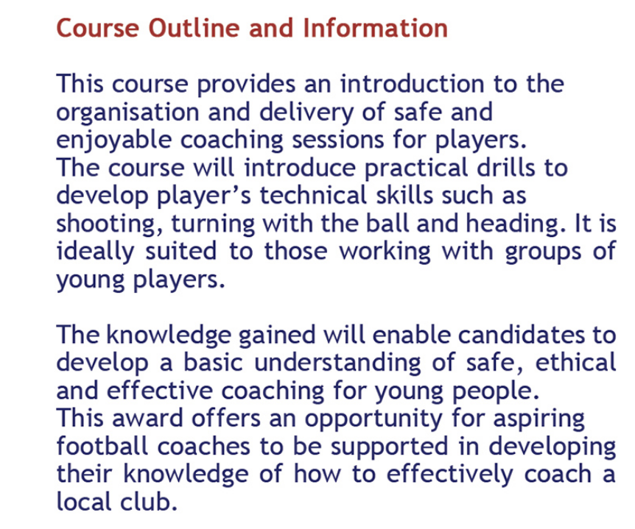
With British Sign Language Support
To book please visit - www.derbyshirefa.com/development and click on
events/bookings
For more information please contact Philippa Bass on either philippa.bass@derbyshirefa.com or 01332 361422 (option 1)

