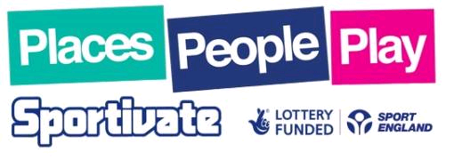
What is Sportivate?
Sportivate is a nationwide campaign that aims to capture the excitement of sport and London 2012 to provide opportunities for teenagers and young adults to receive 6 weeks of coaching in the sport of their choice and guide them into regular participation within their community.
Sportivate is a £32 million National Lottery funded programme and part of the Play strand in Sport England’s mass participation legacy plans ‘People, Places, Play’. The overall aim of the project is to get 300,000 semi sporty participants aged 14 – 25 years to complete weekly coaching sessions with 120,000 (2 in 5) carrying on playing sport regularly.
Project Criteria
Applicants applying for funding should ensure that their projects meet the following criteria and detail this within their applications.
- Activity must target 14-25 year olds
- Activity must run for 6 weeks
- Each session within the activity should be one hour in duration
- Activity to target young people who are not participating regularly in sport in their own time (semi sporty)
- Activities should match as well as generate demand
- Sessions can take place at any time during the day *
- Participants within the sessions should be coached or led and community focused
- Activity must lead to a local exit route or sustainable session (i.e. local sports club/participant funded continuity)
- Activity must be a new initiative or demonstrate additionality over current provision
- Organisations, and their delegated delivery bodies must meet minimum operating standards (further information available on request)
* Excluding curriculum time for projects targeting participants in education

What level of funding can i expect?
All application are assessed on an individual basis however average grant are around the £300 - £400 mark for a project that aims to attract around 10 – 15 people. If you are planning to attract more or run a larger scale programme funding may be more.
THERE ARE NO LIMITS TO THE NUMBER OF TIMES THAT YOU CAN APPLY PROVIDING EACH 6 WEEK ACTIVITY IS TARGETED AT A DIFFERENT GROUP OF PEOPLE. So as a national association you could look to run activity in several geographic areas around your club or volunteer capacity

Monitoring and Evaluation
The aim of the Sportivate projects is to retain 60% of the participants attending. A retained participant is one who is attending at least 5 out of 6 sessions.
Here are some tips to encourage participants to keep attending sessions:
- Run taster sessions before the start of the project to generate interest
- Offer incentives to those participants who attend 5 out of 6 sessions (e.g. Discounted membership/sports equipment)
- Make sure your project will avoid key holiday periods
- Introducing upfront financial commitment
- Texting reminders to participants
To assist Sport England with the evaluation of Sportivate, each successful applicant organisation must collect some basic information about their participants. Participants will be asked to fill out registration forms on attendance of their first session and their attendance needs to be monitored throughout the 6 weeks. On completion of the project the registration forms and attendance record need to be returned to the funding body.
Applications
If you are interested in finding out more about this funding please contact me Lee Dolby. National Inclusive Sport Advisor for UK Deaf Sport on leed@ukds.org.uk and I will work with you to develop an application and submit it to the appropriate County Sport Partnership who coordinate the project in your areas.

