Deaf Cricket Taster Session
In Partnership with the Sports Learning Zone
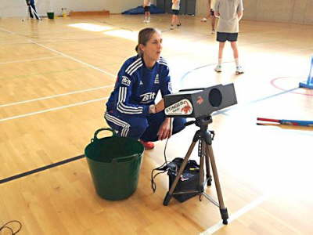
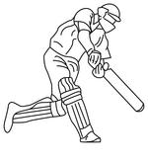
31ST January 2016

Diving Catches! Tennis Ball Machines! Qualified Level 2 Coaches
Location:
Headingley Carnegie Cricket Ground, Yorkshire County Cricket Club, St Michael's Rd, Leeds, West Yorkshire LS6 3BU
Contact- Charlie Roebuck C.roebuck@yorkshirecb or call/SMS 07736294201
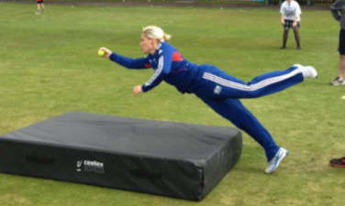
Time: 11am – 1pm
Price: FREE!
Coaches are trained in deaf awareness and BSL Interpreters are present.

